Autenticação Kerberos

Criar Usuário no ad para integração:

Ex: Kerberos

Configurar SPN:
setspn.exe -A HTTP/SERVIDORAD.DOMINIO kerberos
setspn.exe -A HTTP/SERVIDORAD kerberos
setspn.exe -A HTTP/SERVIDORFUSION.DOMINIO kerberos
setspn.exe -A HTTP/SERVIDORFUSION kerberos

Politica de Segurança:
TRADUZIR(OBSERVAÇÃO TEMOS QUE ATIVAR TUDO)
In Active Directory environments, the Kerberos etypes can be configured in Group Policy in the following location: Computer Configuration\Policies\Windows Settings\Security Settings\Local Policies\Security Options\Network security: Configure encryption types allowed for Kerberos. If left undefined, which is the default setting, Active Directory will use the higheststrength algorithm. Also note that the DES encryption types have been deprecated in Server 2008 and higher. If legacy Kerberos systems require these, you must define a policy and link it to your domain.

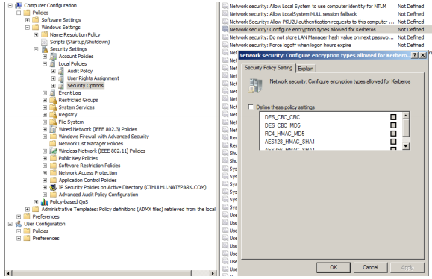

In Active Directory, also check the user’s settings in the Account tab for the following values: Use Kerberos DES encryption types for this account This account supports Kerberos AES 128 bit encryption. This account supports Kerberos AES 256 bit encryption. If in a mixed environment with Domain Controllers running Windows 2000/2003 and DCs running 2008+, enabling AES on the account may cause issues if a user’s TGT session keys are generated with AES and the user attempts to use these session keys for Service Tickets generated on Windows 2000/2003 DCs. Additionally, DES encryption types were deprecated with Windows 2008, so if account principals are configured to use DES, you must either: 1) enable DES via Group Policy as described above; or 2) disable DES on the account options.

Todos usuários deverão ter habilitados a criptografia de comunicação.
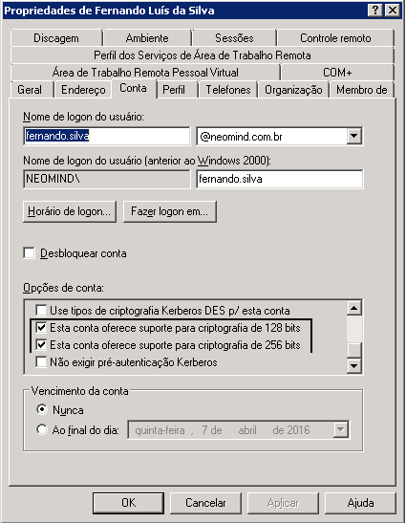

Configuração Navegadores:
IE
Ir em Opções de Internet:

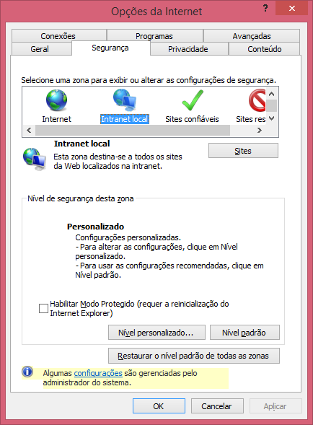

Abrir a guia Segurança e ir em Intreanet Local / Sites, e marcar as seguintes opções:
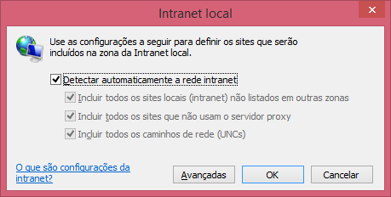
Ir em Avançadas: e adicionar o servidor do Fusion como zona confiável ex:
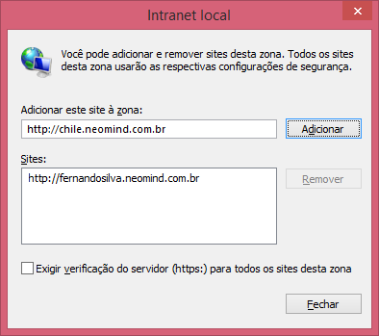

Ir em Opções da Internet / Avançadas e marcar a opção: Habilitar a Autenticação Integrada do Windows

